**REVISION 1**

1. **Complete the sentences with the words in the chart.**
2. **Match the sentences to the pictures.**

|  |  |  |
| --- | --- | --- |
| Subject pronouns | Verb Be | Possessive adjectives |
| I  He  They | ‘m (x 2)  Is (x 4)  ‘s (x 2)  Are | My  His (x 2)  Her  Their |

1. Game development …1 the process of creating a game.
2. There … 2 several members in a game development team.
3. These are Monica, Luis and Juan. …3 are game designers. …4 job …5 to design the gameplay.
4. Hi. I …6 Mia. …7 ‘m a sound engineer. I…8 responsible for sound effects and sound positioning.
5. This …9 Neil. …10 ‘s a level designer. …11job is to create levels, challenges or missions for video games.
6. This …12 Lina. She …13 a game artist. …14 area is video game art.
7. 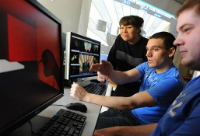This …15 Sean. He …16 a game programmer. …17 job is to develop the game codebase[1].

1 2 4

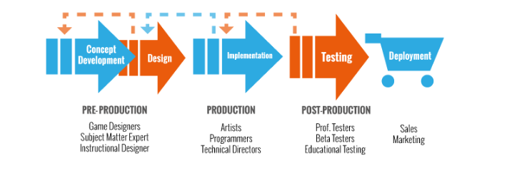

5

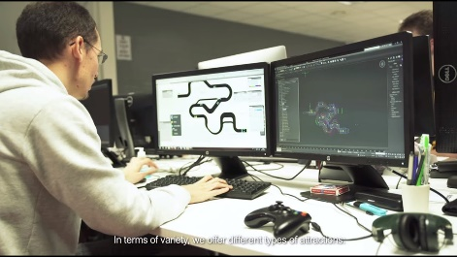6 7

**c. You are at the reception desk of a game developers conference in Berlin:**

**1. Invent an identity: name, job, company, phone number.**

**2. Write a conversation between you and the receptionist asking and giving personal information. Use the following dialogue as a model[2]:**

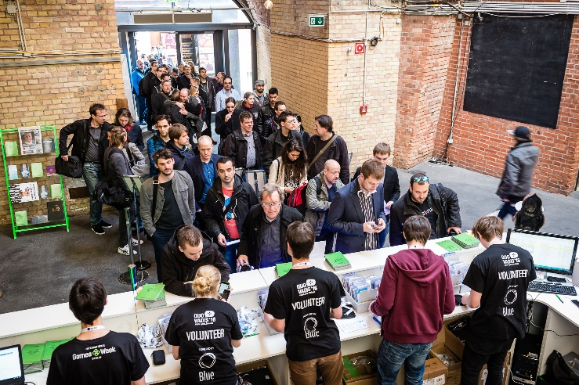R: Good morning. What’s your name, please?

L: Hi. My name’s Schultz.

R: Can you spell that?

L: Yes. S-C-H-U-L-T-Z: Shultz.

R: What’s your first name?

L: Liam: L-I-A-M.

R: Thank you. What’s your job?

L: I’m a photographer. I’m from *Today* magazine.

R: OK. Sign here, please[3].

L: OK. Thanks. Bye.

R: Goodbye.

1. Base de código.
2. Estás en la recepción de una conferencia internacional de desarrolladores de videojuegos. 1. Inventá una identidad: nombre, trabajo, empresa, N° de teléfono. 2.Escribí una conversación entre vos y la recepcionista pidiendo y dando información personal. Usá el siguiente diálogo como modelo:
3. ‘Firme acá por favor.’